Unit 3 java exception handling programme

Q1:- 1.     Write a Java program to illustrate usage of try\catch with finally clause

// File Name : ExcepTest.java

import java.io.\*;

public class ExcepTest {

public static void main(String args[]) {

try {

int a[] = new int[2];

System.out.println("Access element three :" + a[3]);

} catch (ArrayIndexOutOfBoundsException e) {

System.out.println("Exception thrown :" + e);

}

System.out.println("Out of the block");

}

}

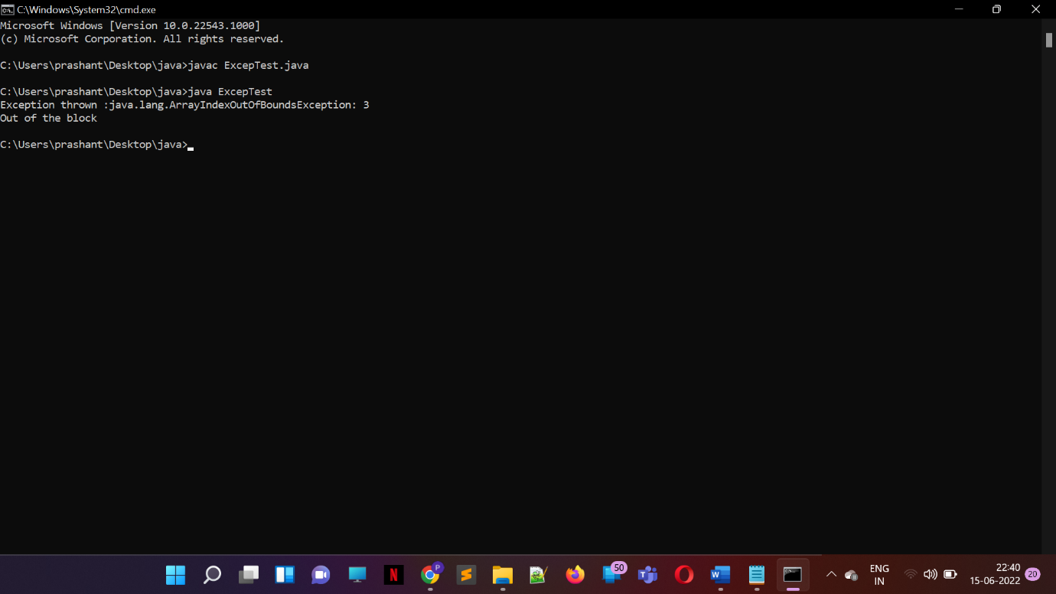

Q2:- 2.     Write a Java program to describe usage of throws clause

import java.io.IOException;

class Testthrows1{

void m()throws IOException{

throw new IOException("device error");//checked exception

}

void n()throws IOException{

m();

}

void p(){

try{

n();

}catch(Exception e){System.out.println("exception handled");}

}

public static void main(String args[]){

Testthrows1 obj=new Testthrows1();

obj.p();

System.out.println("normal flow...");

}

}

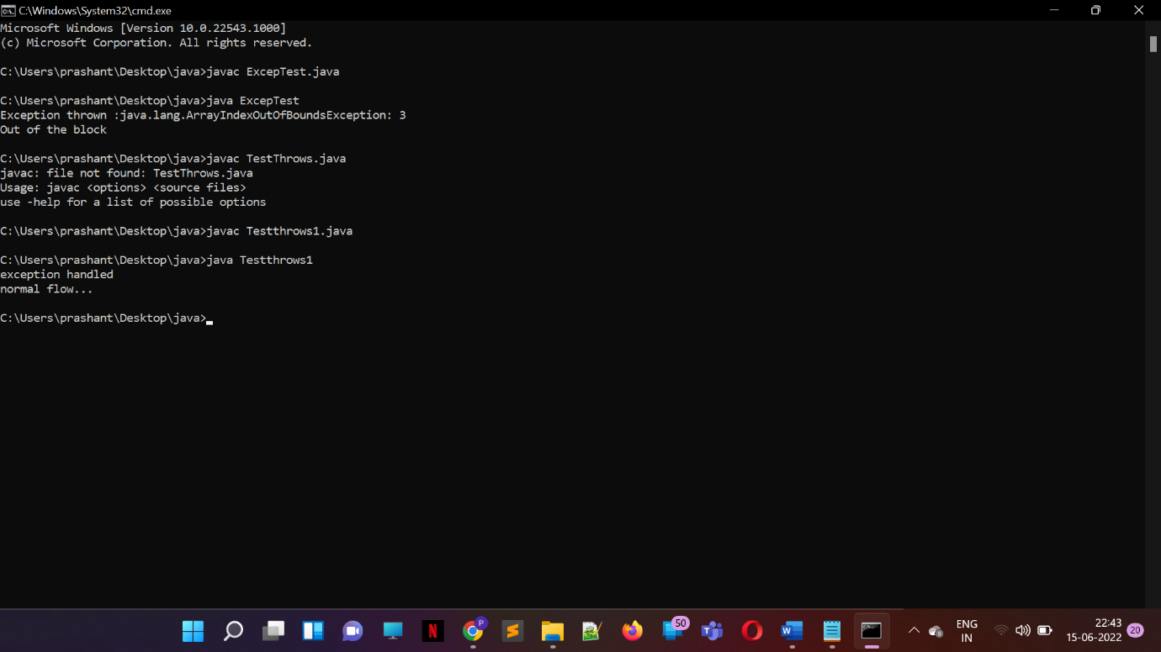

Q3:- 3.     Write a Java program for creation of user defined exception.

// A Class that represents use-defined exception

class MyException extends Exception {

public MyException(String s)

{

// Call constructor of parent Exception

super(s);

}

}

// A Class that uses above MyException

public class Main {

// Driver Program

public static void main(String args[])

{

try {

// Throw an object of user defined exception

throw new MyException("GeeksGeeks");

}

catch (MyException ex) {

System.out.println("Caught");

// Print the message from MyException object

System.out.println(ex.getMessage());

}

}

}

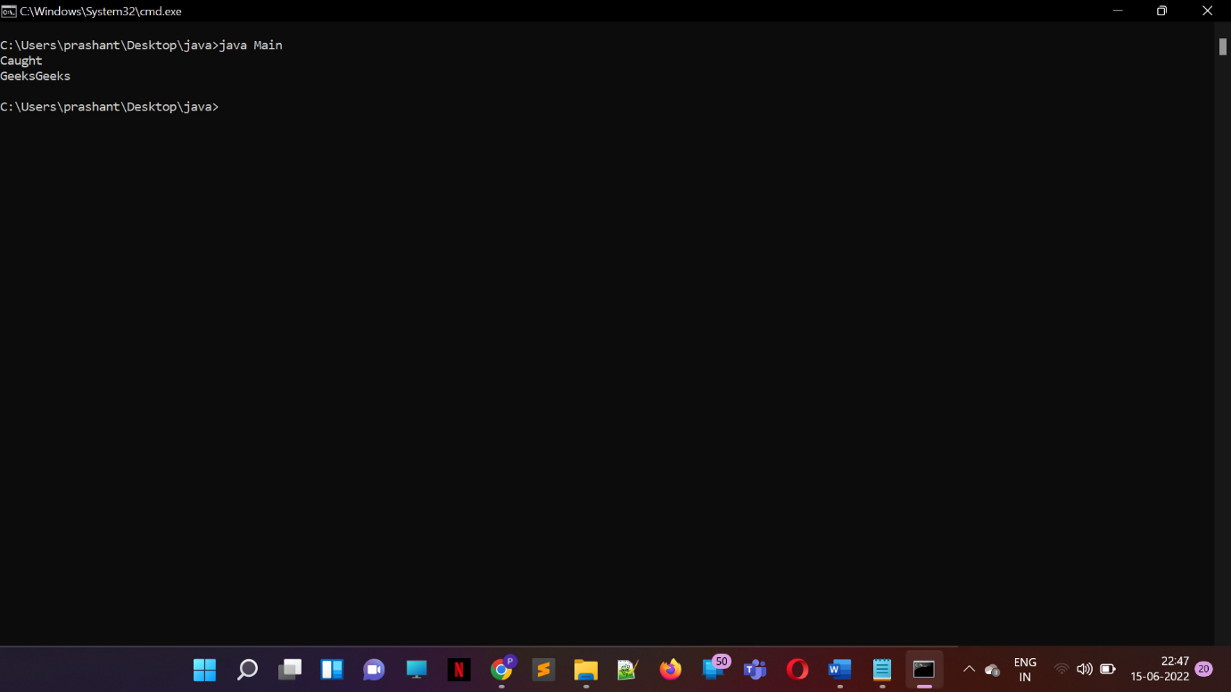

Q4:-

class Customer extends RunTimeException

{

private String custNo;

private String custName;

private String category;

Customer(String custNo,String custName,String category)

{

this.custNo=custNo;

this.custName=custName;

this.category=category;

}

public static void main(String[] args)

{

Custome c=new Customer(001,"c1","platinum");

}

}

Q5:- Write a Java program to create a text file in the path c:\Java\abc.txt and check whether that file exists or not. Using the command exists(), isDirectory(), isFile(), getName() and getAbsolutePath().

import java. io.\*;

class FileMethods1

{

public static void main(String args[ ] )

{

File f1 = new File( “c:\\java”, “abc.txt”) ;

System.out.println(“File name :” + f1.getName());

System.out.println(“path :” + f1.getPath());

System.out.println(“Absolute path :”+f1.getAbsolutePath());

System.out.println(f1.exists() ? “file exists”

: “file does not exists”);

System.out.println(f1.isDirectory() ? “file is a directory”

: “file is not” + “ a directory”);

System.out.println(f1.isFile()? “file is an ordinary file”

: “file may be a named pipe”) ;

}

}